CASE STUDY
AI Marketing Agent Platform

EXECUTIVE SUMMARY
Manual marketing workflows slowed campaign velocity and limited personalization at scale.
The AI Marketing Agent Platform unified AI content generation, trend intelligence, workflow automation, and enterprise-grade infrastructure within a scalable microservices ecosystem.
Result: 120% increase in content output, 45% faster campaign launches, and 52% reduction in manual drafting effort — without expanding the team.

1. Problem Statement

Industry / Customer Context
Growth-stage and mid-market companies running multi-channel marketing across social media, blogs, paid ads, email, and website funnels. Marketing teams of 3–15 members managing 5–10 active campaigns monthly.

Core Problem Identified
Marketing execution was fragmented across tools, with manual content creation, inconsistent brand messaging, and limited performance visibility. Teams struggled to scale content output without increasing headcount.

Supporting Data Points (Baseline Metrics)
Metric | Baseline
Avg. time to produce one campaign (multi-channel) | 5–7 days
Content production per week | 8–12 assets
Content repurposing rate | <20%
Brand voice inconsistency across channels | High variance
Time spent on repetitive content drafting | 40–50%
Campaign experimentation cycles | 1–2 per month
Lead conversion from organic channels | 2–3%

Why It Mattered
- Slow go-to-market cycles
- High dependency on manual ideation
- Inconsistent brand positioning
- Limited personalization at scale
- Poor cross-channel performance visibility

Marketing velocity was directly limiting revenue acceleration.

2. Impact of the Problem
(Functional, Emotional & Social Pain)

Operational Pain
- Switching between 6–10 tools for campaigns
- Manual competitor research and trend analysis
- Content calendar management in spreadsheets
- No unified AI-driven personalization
- Publishing delays due to fragmented workflows

Emotional Impact
- Marketing managers constantly in execution mode
- Creative fatigue due to repetitive drafting
- Pressure to deliver performance without scalable systems

Social / Organizational Consequences
- Misalignment between content, growth, and product teams
- Delayed campaign launches
- Low confidence in performance forecasting

Cost of Inaction
If unchanged:
- 30–40% slower campaign launches
- Rising marketing acquisition costs
- Content saturation without differentiation
- Need to hire 2–3 additional marketers to maintain output

3. Solution Provided
(Pain Relievers & Gain Creators)

Solution Overview
AI Marketing Agent Platform — a scalable, microservices-based marketing automation ecosystem that integrates AI-driven content generation, workflow automation, publishing, analytics, and multi-tenant enterprise infrastructure.

Key Features Implemented
AI Content Generation Engine (MCP Server)
→ Pain Relieved:
- Automated brand voice content creation
- Target audience personalization
- Multi-model AI support (OpenAI, Gemini, Claude, Azure OpenAI)
- Reduced manual drafting time
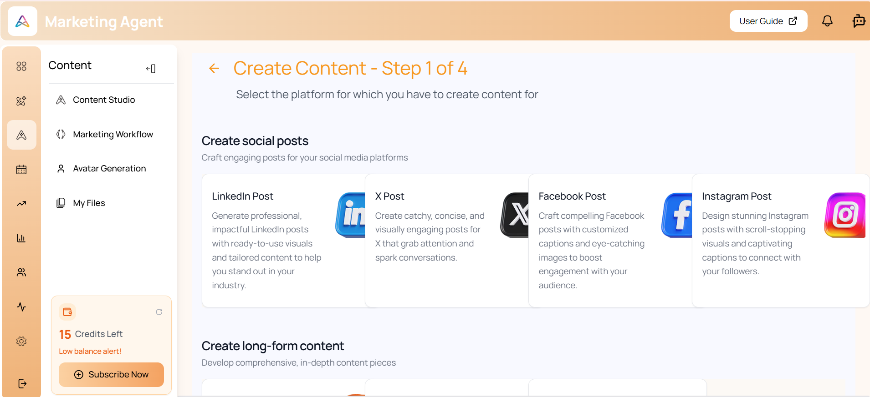

Trend Analysis & Scraping Engine
→ Gain Created:
- Competitor analysis
- Automated trend discovery
- Query generation for deep research
- Improved content relevance
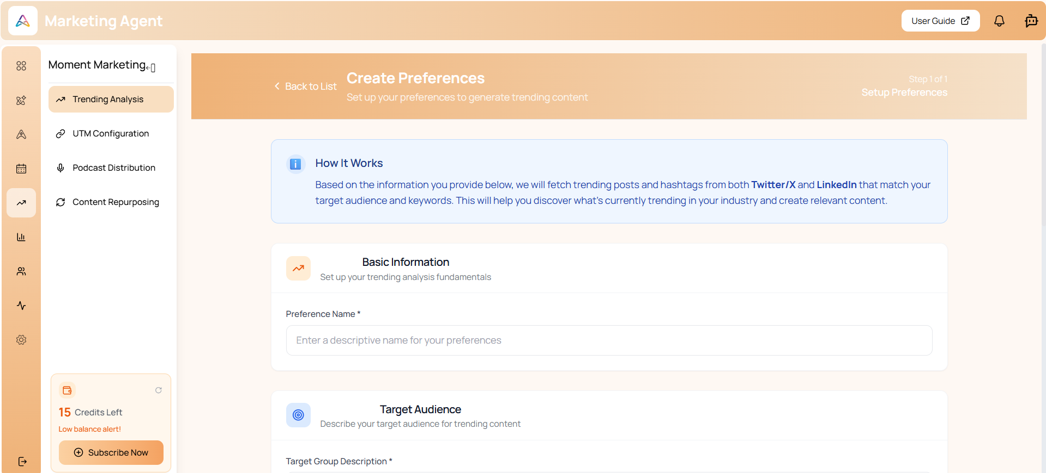

Workflow & Publishing Automation
→ Efficiency Impact:
- Content calendar management
- Social media publishing integrations
- Automated scheduling
- Campaign orchestration
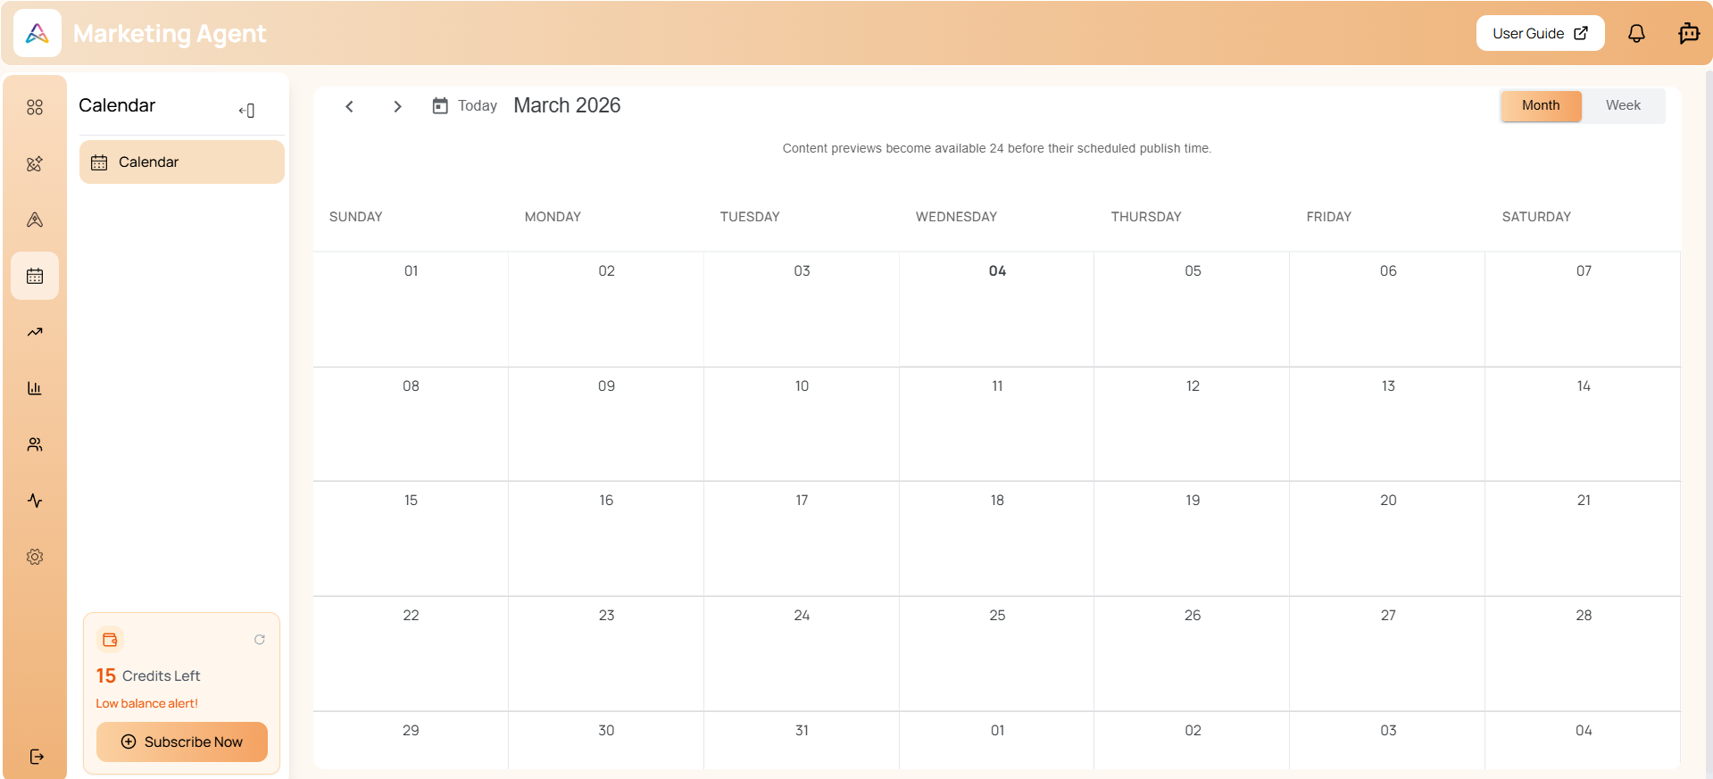

Core Infrastructure Layer
→ Enterprise Scalability:
- JWT-based authentication
- Role-Based Access Control (RBAC)
- Wallet & subscription management
- Multi-tenant MySQL architecture
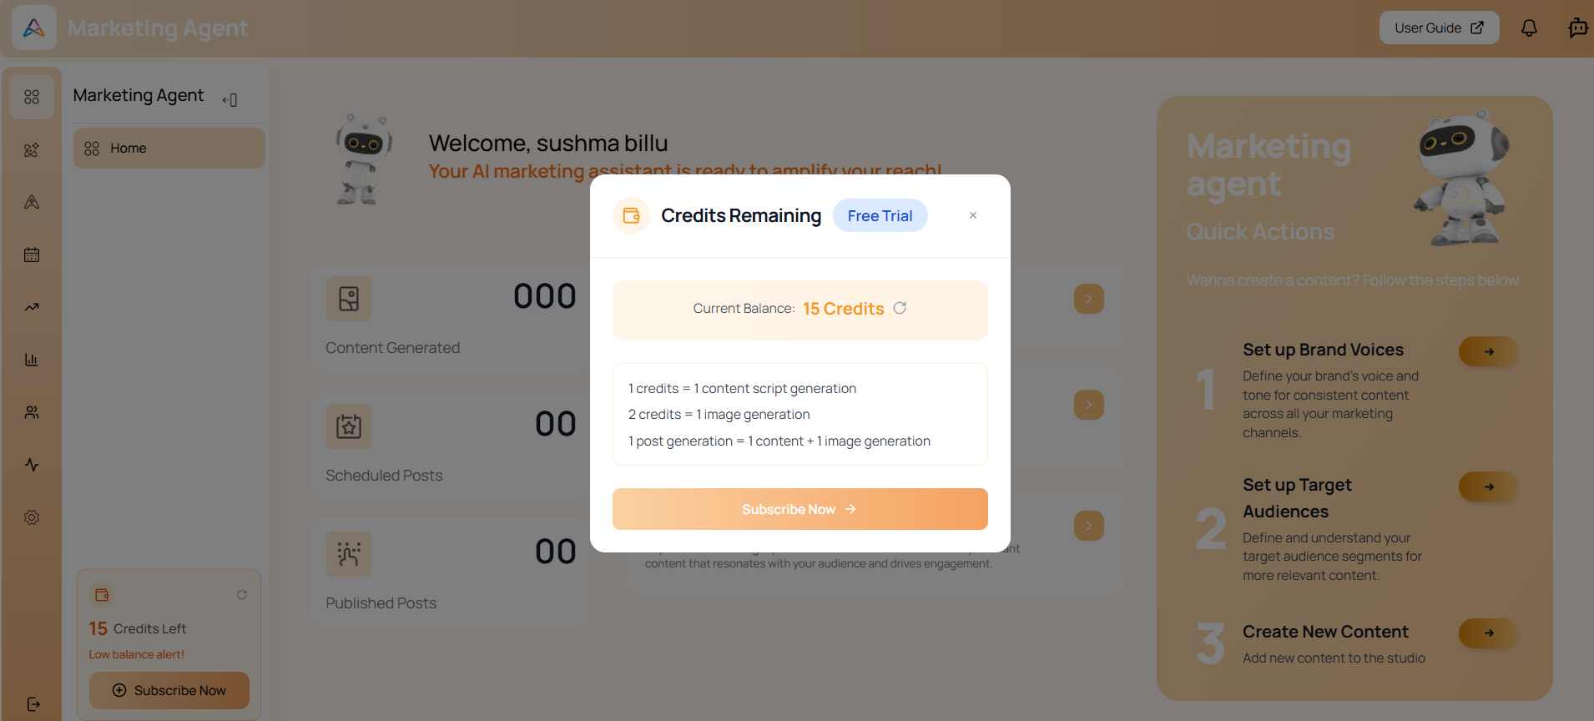

Microservices Architecture
→ Performance & Modularity:
- API Gateway for routing
- Registry for service discovery
- Schedulars for background automation
- File Manager & AI Image Generation services

Implementation Approach
Timeline:
- Week 1–2: Core backend & authentication setup
- Week 3: AI content engine deployment
- Week 4: Scraping & trend analysis integration
- Week 5: Publishing workflows & calendar rollout
- Week 6: Dashboard analytics & performance tracking

Integration Complexity:
- Nx monorepo (Frontend)
- Golang microservices with Go workspaces
- Python MCP server for AI tool execution
- Node.js scraping backend
- Dockerized container deployment
Change Management Strategy:
- Marketing team onboarding to AI workflows
- Prompt optimization sprints
- Gradual transition from manual drafting to AI-assisted production
- KPI-based iteration cycles

Technical Capabilities & Architecture
Layered Architecture

Frontend (React + TypeScript SPA)
↓
API Gateway (Go + JWT Middleware)
↓
Core Services (User, Company, RBAC, Payments, Wallet)
↓
Marketing AI Services (Python MCP + Node Scraping)
↓
Infrastructure Services (Registry, File Manager, Schedulars, Sutra, IGM)
↓
MySQL Multi-Tenant Database

Key Technical Components
- JWT-based secure authentication
- Multi-tenant database isolation
- GORM ORM with structured entity relationships
- Swagger-based API documentation
- Docker-based deployment pipelines
- CI/CD environment separation (Staging & Production)
- AI-powered image generation (IGM service)

4. Outcome (Quantified Results)

Measurable Results (Within 90 Days)
Metric | Result
Content production increase | 120%
Campaign launch time reduction | 45%
Content repurposing rate | <20% → 70%
Manual drafting time reduction | 52%
Experimentation cycles per month | 2 → 6
Organic lead conversion improvement | 3% → 5.4%

Strategic Impact
- Scalable content engine without proportional hiring
- Faster go-to-market execution
- Consistent cross-channel brand voice
- Improved campaign analytics visibility
- Structured subscription and credit monetization model

Human Impact
- Reduced creative fatigue
- Improved collaboration between marketing and growth teams
- Higher confidence in campaign forecasting
- Teams shifted from execution-heavy work to strategic experimentation

